Activity: • Build a spring pet clinic application using Jenkins by a continuous delivery pipeline • Steps: • Create a Freestyle project and name it as PetClinicCompile • Provide the repository path in Source Code Management section : https://github.com/AnjuMeleth/spring-petclinic.git • Select “Invoke top level maven target” under “Build” section. Set the goal as “compile” under the correct installation • Save the configuration and Build Now • Definition of Done: • Upload the screenshot of Jenkins dashboard -> Output to the GitHub under the folder Task10

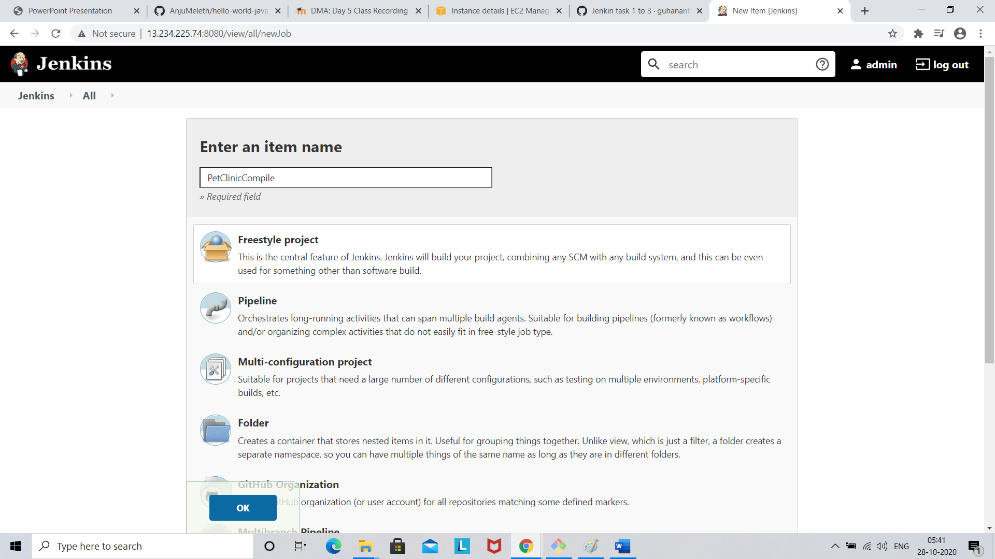

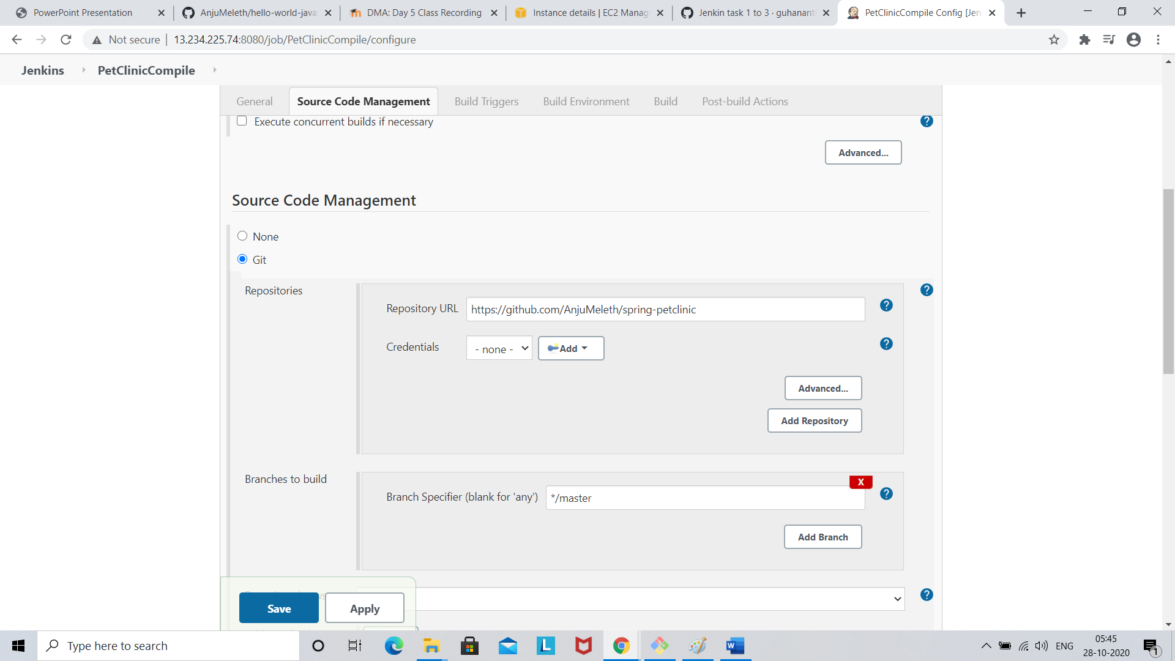

Select “Invoke top level maven target” under “Build” section

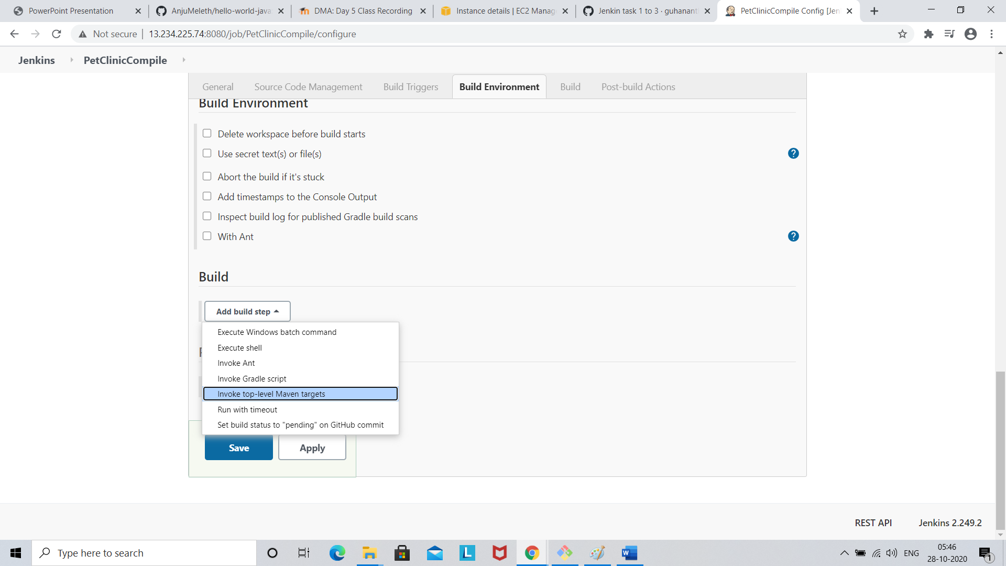

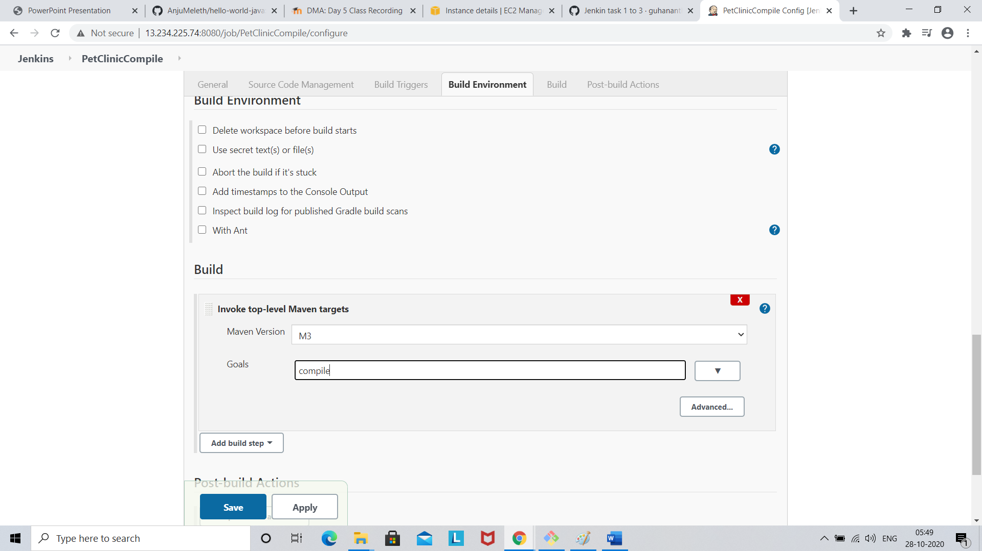

Click save

Now click Build now option

